**PIZZA SALES SQL**

**KPI**

1. **TOTAL REVENUE:**

select sum(total_price) as Total_Revnue from pizza_sales;

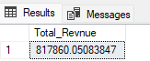

1. **AVERAGE ORDER VALUE:**

SELECT SUM(total_price)/count(distinct order_id) as Average_order_Value from pizza_sales;

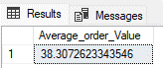

1. **TOTAL PIZZA SOLD**:

select sum(quantity) from pizza_sales;

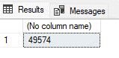

1. **TOTAL ORDER:**

SELECT count(distinct order_id) as total_order from pizza_sales;

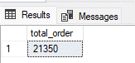

1. **Average Pizza Per Order:**

select cast(cast(sum(quantity) as decimal(10,2))/ cast(count(distinct order_id) as decimal(10,2)) as decimal(10,2)) as Average_Pizza_Per_Order from pizza_sales;

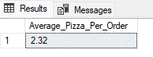

1. **DAILY TREND OF TOTAL ORDERS:**

select DATENAME(DW, order_date) as order_day, count(distinct order_id) as Total_orders

from pizza_sales

group by DATENAME(DW, order_date);

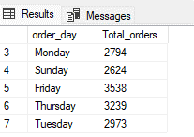

1. **MONTHLY TREND OF TOTAL ORDERS:**

select DATENAME(MONTH, order_date) as order_MONTH, count(distinct order_id) as Total_orders

from pizza_sales

group by DATENAME(MONTH, order_date)

order by Total_orders;

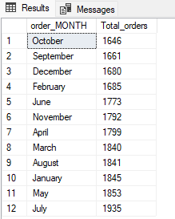

1. **PERCENTAGE OF SALES BY PIZZA CAREGORY:**

SELECT pizza_category, sum(total_price) as Total_Sales, sum(total_price)*100/ (select sum(total_price) from pizza_sales) as PCT_sales

from pizza_sales

group by pizza_category;

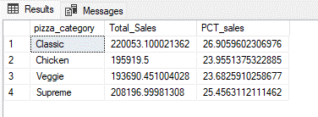

1. **PERCENTAGE OF SALES BY PIZZA CATEGORY FOR JANUARY:**

SELECT pizza_category, sum(total_price) as Total_Sales, sum(total_price)*100/ (select sum(total_price) from pizza_sales where DATEPART(QUARTER, order_date) = 1) as PCT_sales

from pizza_sales

where DATEPART(QUARTER, order_date) = 1

group by pizza_category;

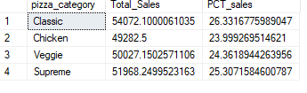

1. **PERCENTAGE OF SALES BY PIZZA CATEGORY FOR JANUARY:**

SELECT pizza_size, cast(sum(total_price) as decimal(10,2)) as Total_sales,

CAST(sum(total_price)*100/(select sum(total_price) from pizza_sales) AS DECIMAL(10,2)) as PCT_sales

from pizza_sales

where datepart(quarter, order_date)=1

group by pizza_size

order by PCT_sales desc;

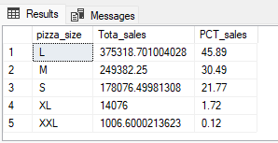

1. TOP 5 PIZZA BY REVENUE:

with Pizza_by_Revenue as (select pizza_name, sum(total_price) as Total_Revenue from pizza_sales

group by pizza_name

)

select top 5 * from Pizza_by_Revenue

order by Total_Revenue desc;

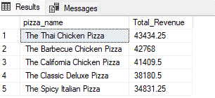

1. TOP 5 PIZZA BY ORDER:

with Pizza_by_order as (select pizza_name, count(distinct order_id) as Total_Orders from pizza_sales

group by pizza_name

)

select top 5 * from Pizza_by_order

order by Total_Orders desc;

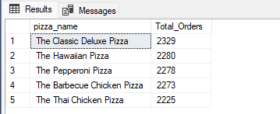

1. TOP 5 PIZZA BY QUANTITY:

with Pizza_by_quantity as (select pizza_name, sum(quantity) as Total_quantity from pizza_sales

group by pizza_name

)

select top 5 * from Pizza_by_quantity

order by Total_quantity desc;

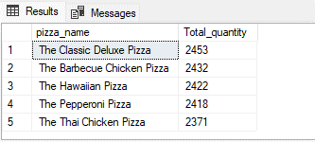

1. BOTTOM 5 PIZZA BY REVENUE:

with Pizza_by_Revenue as (select pizza_name, CAST(sum(total_price) AS DECIMAL(10,2)) as Total_Revenue from pizza_sales

group by pizza_name

)

select top 5 * from Pizza_by_Revenue

order by Total_Revenue;

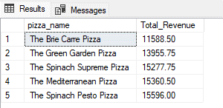

1. BOTTOM PIZZA BY ORDER:

with Pizza_by_Order as (select pizza_name, count(distinct order_id) as Total_order from pizza_sales

group by pizza_name

)

select top 5 * from Pizza_by_Order

order by Total_order;

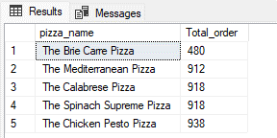

1. BOTTOM PIZZA BY QUANTITY:

with Pizza_by_quantity as (select pizza_name, SUM(quantity) as Total_quantity from pizza_sales

group by pizza_name

)

select top 5 * from Pizza_by_quantity

order by Total_quantity;

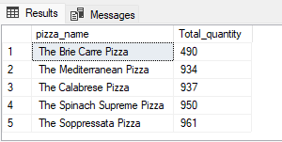

**FILTERING THROUGH THE RESULTS:**

* SELECT pizza_category, sum(total_price) as Total_Sales, sum(total_price)*100/ (select sum(total_price) from pizza_sales) as PCT_sales

from pizza_sales

where MONTH(order_date) = 1

group by pizza_category;

* SELECT pizza_category, sum(total_price) as Total_Sales, sum(total_price)*100/ (select sum(total_price) from pizza_sales) as PCT_sales

from pizza_sales

where DATEPART(QUARTER, order_date) = 1

group by pizza_category;